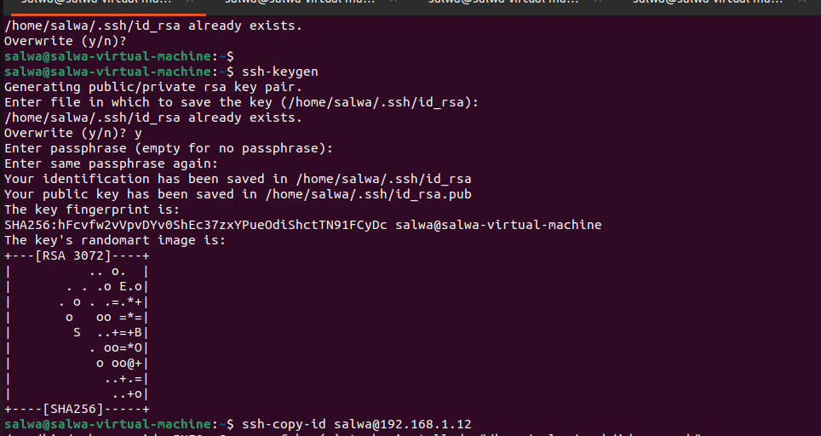

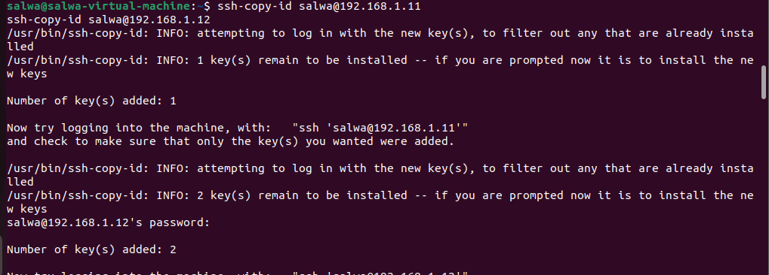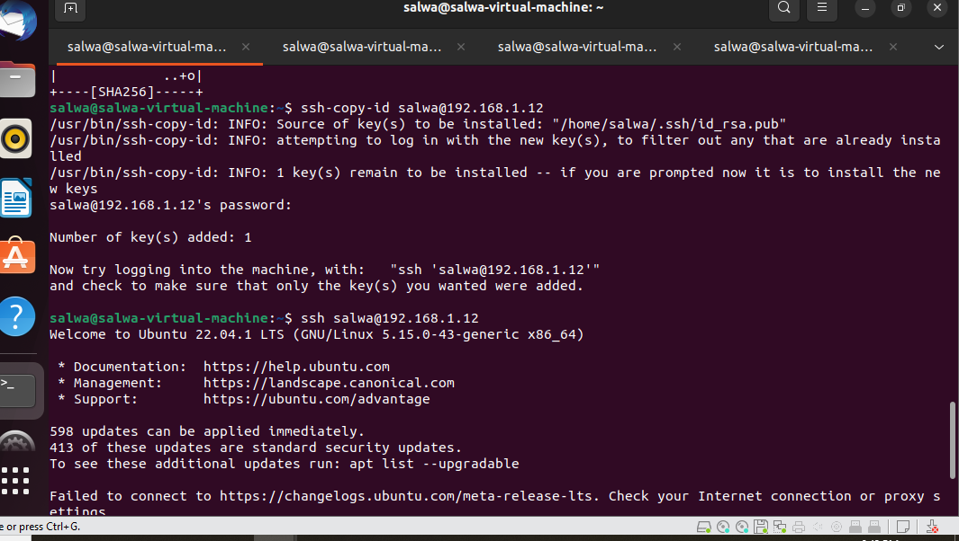

Confuguration /homse/salwa/dns-configuration/templates/named.conf.options .j2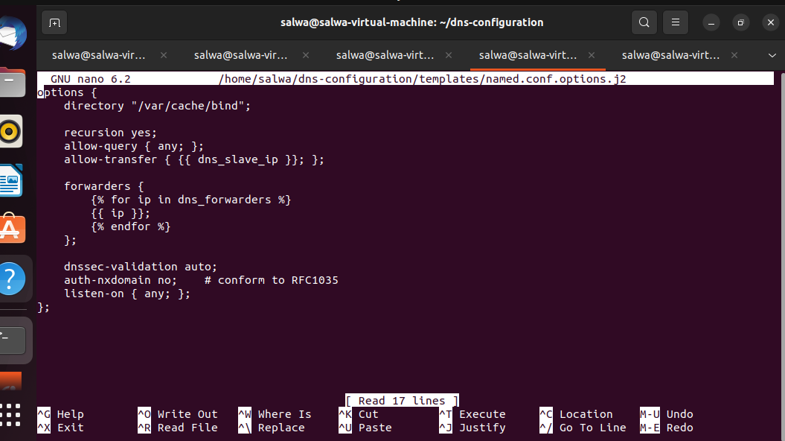

mkdir -p ~/dns-configuration/templates

nano ~/dns-configuration/templates/named.conf.local.master.j2
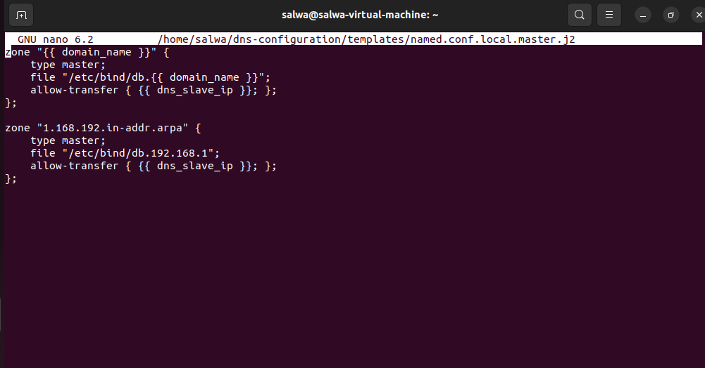

nano ~/dns-configuration/templates/named.conf.local.slave.j2
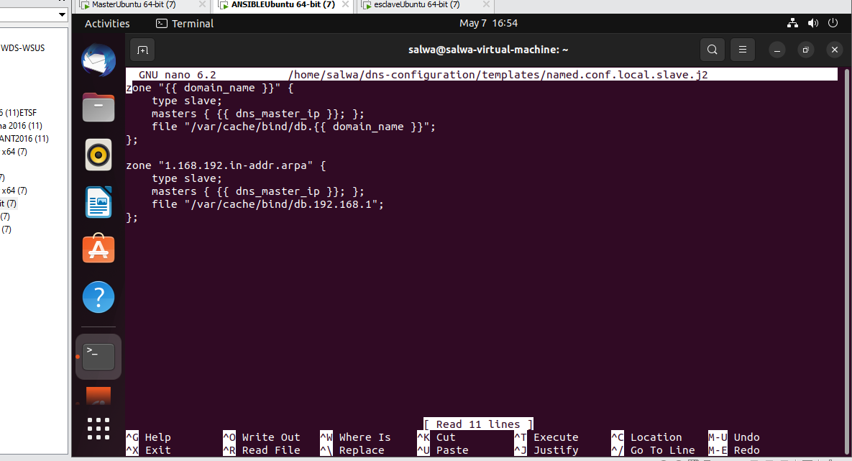
nano ~/dns-configuration/templates/db.zone.j2
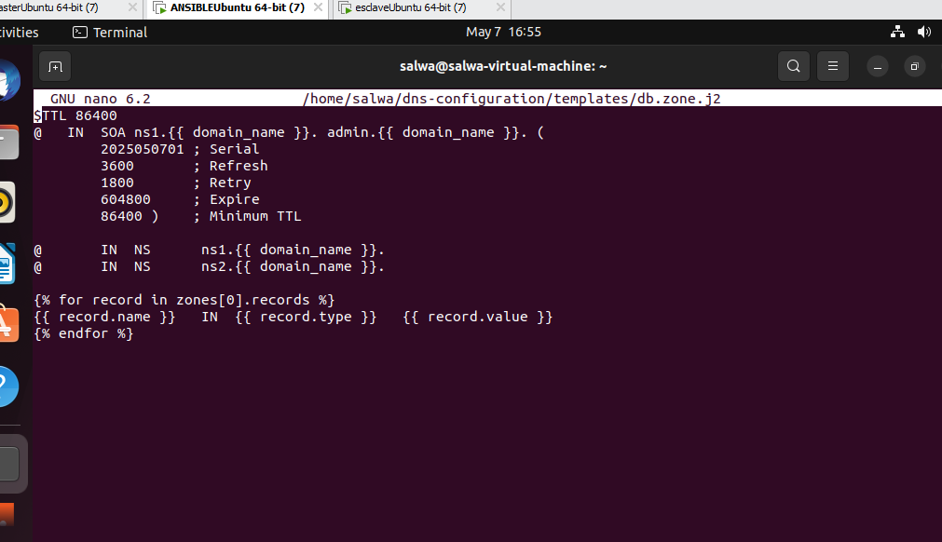
nano ~/dns-configuration/templates/db.reverse.j2
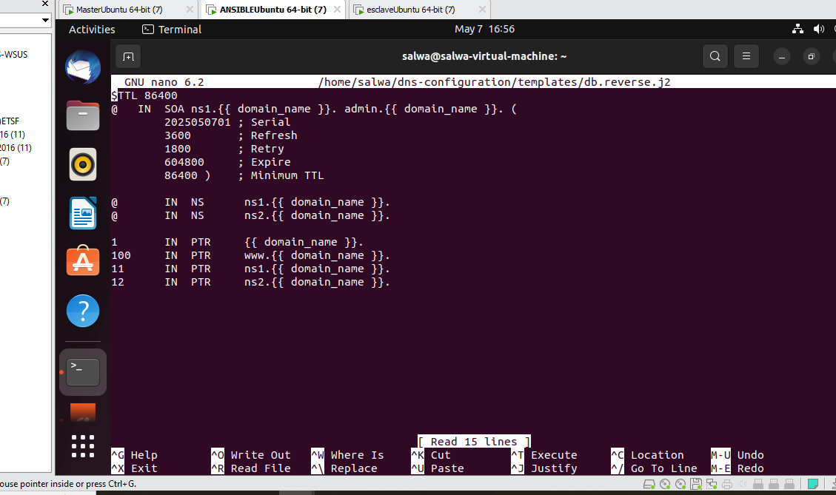

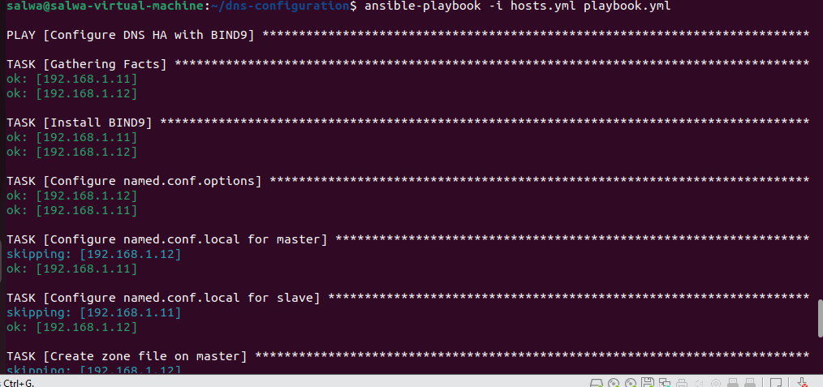
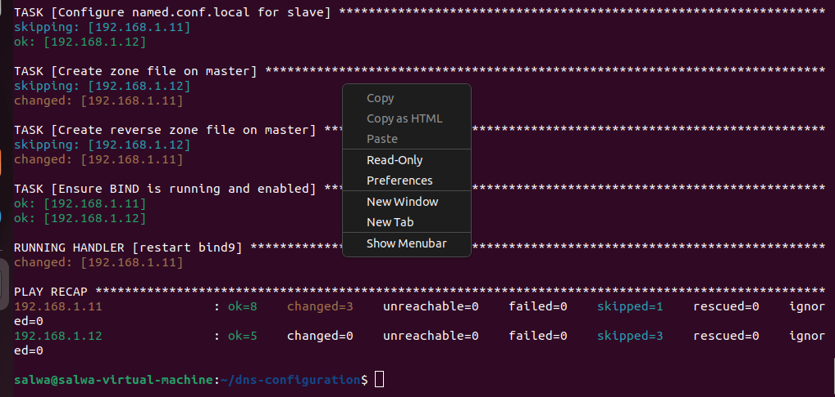

SUR MASTER

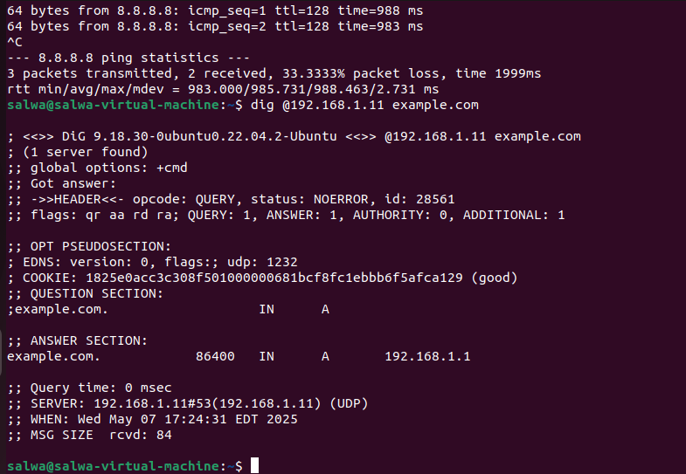
SUR SLAVE 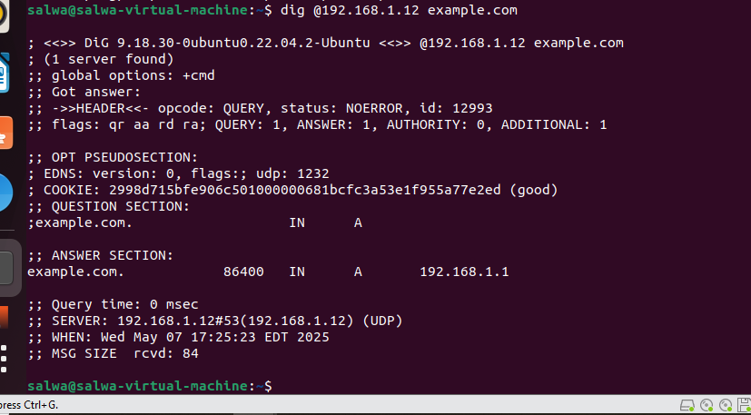
ON STOP SERVER MASTER
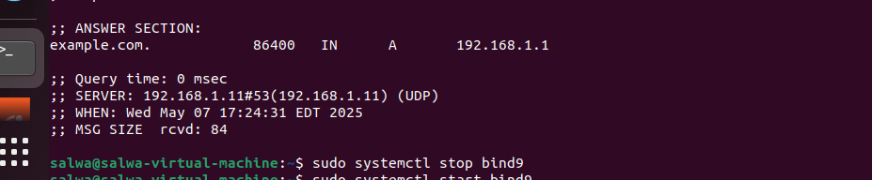
FAIRE TESTE SUR ANSIBLE LE SERVEUR SLAVE REPOND
